T-Scan – Content Creation and Strategy
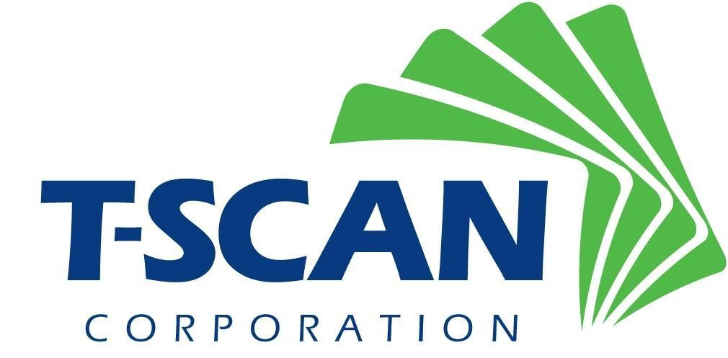
Client Need
T-Scan is the leading record retrieval service provider for full-service litigation support based out of Seattle, WA. T-Scan was looking for a partner to help create marketing content and build out their website copy in order to establish themselves in the overall competitive landscape. They were looking for a technical yet trustworthy partner, someone who was able to take complex legal jargon and turn it into digestible and persuasive content, for all different mediums.
What We Did
Affirma began by cultivating T-Scan’s leadership in their sector through their website content – writing all of T-Scan’s various product offerings, company business, and blog content. By researching, writing, and SEO optimizing blogs with topics ranging from litigation legislation to T-Scan’s company culture, Affirma began posting blogs on a weekly cadence. Affirma wrote and created T-Scan’s marketing assets and any corresponding landing pages, which included various technically challenging whitepapers. In addition to blog and asset content, Affirma took over and revitalized T-Scan’s email campaign strategy by writing targeted email copy to help generate and nurture more leads.
Results
Partnering with Affirma to lead their content writing creation and strategy has allowed T-Scan to rank higher in organic search engine rankings. T-Scan’s weekly blog continues to achieve consistent audience traffic every week and T-Scan’s whitepapers continue to gain traction while growing their leadership in the legal industry. Affirma is now T-Scan’s trusted partner in all things relating to content.

